Date: 10/09/2026
Start Time: 05:11 PM End Time: 06:00 PM
- About us - What we mfg. remove, don't show product 2 times. – talk with Pramod sir – Pramod sir he will discus with DNG
- About us: - Remove corporate video. - talk with Pramod sir - Pramod sir he will discus with DNG
- Product: -
    - product write mtl name. AISI 1065-86 & remove Through Hardened. -OK
    - Write AISI in caps. - OK
    - Rename High Carbon Chrome Alloy Balls as High Carbon High Chrome Steel Balls. - OK
    - Write Ball as “Balls”- Recheck
    - Rename AISI S-2 Tool Steel Balls as Tool Steel Ball AISI S2. - OK
    - just add Ball after Stainless Steel - OK
    - Remove this heading in outer layout. – OK

    - Balls in 3 item Nonferrous.
      - Tungsten Carbide Cobalt Binder Balls OK
      - Tungsten Carbide Nickel Binder Balls OK
      - Titanium Alloys Balls OK
    - Rollers Taper photo incorrect. – adjust photo properly
    - Spherical Rollers add, check photo of Needle. (I’LL GIVE PHOTO) - adjust photo properly , I had also given photos of cylindrical & needle roller change it
    - material as per requirement. (check Catalogue) - OK
Add one line stating tat size & material as per your requirement / drawing.
    - write size range & Data sheet similar info of main product.
    - Change Burnishing Media to Steel Ball - Grinding Media
& remove Zirconia Ceramic from it ( cannot be changes as it includes cones & all)
    - Casting Iron Ball Grinding Media – add in grinding media will give you details – take some ai generated photo

Page 2 (Second Image)
- Write AISI in Ball Valve Stem Pin in front of - ok
AISI 304/304L, AISI 316/316L, Hastelloy, K Monel 400/500, Inconel 725/825, Duplex.
- AISI 304/304L, AISI 316/316L, AISI 420/420C, AISI 440C, Hastelloy, K Monel 400/500, Inconel 725/825, Duplex, Stelite in Valve Balls – correction in Stellite
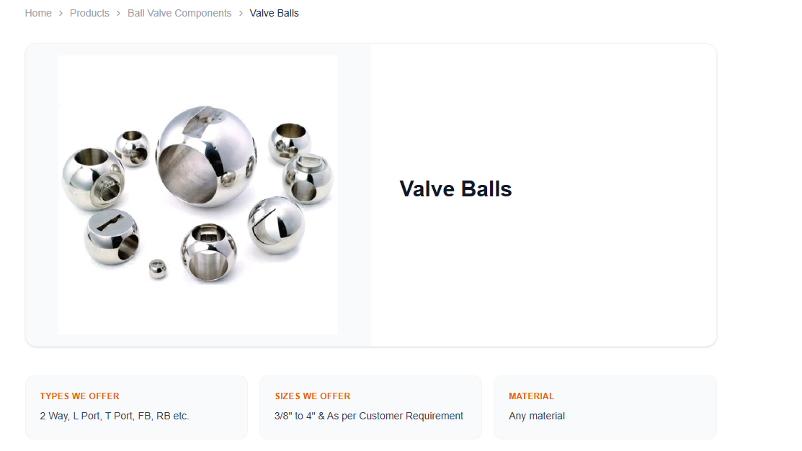
- Change view of this after view product - ok
- Instead of view product write View Details. - ok

- For Photo of Engineering Mfg use this for photo generation Guide Way, Ball screw & liner motion for photo of Mfg engineering. - ok
- Add 1 more industries Paint & Pigment.- ok
- Add get in touch content in inquiry form – ok
- Keep only phone no +91-22-68380200 (100 Lines) in contact remove mob no – keep tele phone no one time
- Email - enquirybr@ngandhi.com

- NAMTPL
- All ok
- Add one more product. Will discuss on call about it – I need to discuss with dng
- Mail Id -enquirymatl@ngandhi.com -ok
- Keep only phone no +91-22-68380200 (100 Lines) (“L” in caps)

